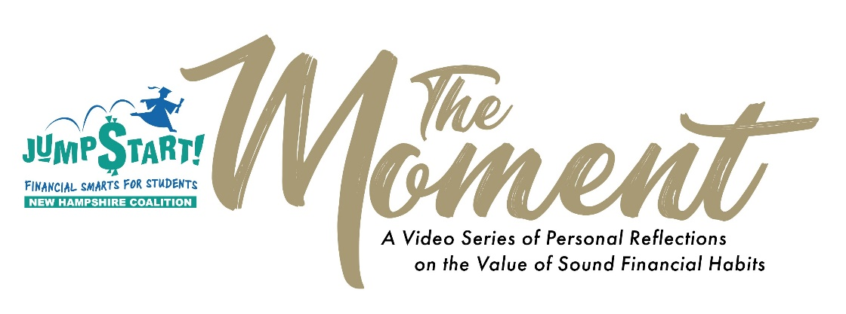

Video Release Authorization

I, Click or tap here to enter text. hereby grant and authorize the NH Jump$tart Coalition (NHJSC) the right to edit, copy, exhibit, publish, and make limited use of video provided by me specifically for “The Moment” campaign; and to be used exclusively on the NHJSC social media platforms and website.

This authorization extends to all languages, media, formats, now known or later discovered.

This authorization shall continue indefinitely unless I otherwise revoke this authorization in writing.

I waive the right to inspect or approve any finished product in which my likeness appears.

I agree that I have not been compensated for this use of my likeness. I waive any right to royalties or other compensation arising or related to the use of the video.

I understand and agree that these materials shall become the property of NHJSC and will not be returned. I hereby hold harmless and release NHJSC from all liability, petitions, and causes of action which I, my heirs, representatives, executors, administrators, or any other persons may make while acting on my behalf or on behalf of my estate.

Please label my submitted video: (choose one)

☐ Name, Title, Company, City, State

☐ Name, City, State

☐ First Name, Last Name Initial, City, State

☐ First and Last Name Initials Only, City, State

Signed: _____________________________________________

Name: Click or tap here to enter text.

Date: Click or tap here to enter text.

Please sign, scan and return this agreement by email to Daniel Hebert, State President, NH Jump$tart Coalition at dhebert@nhjumpstart.org

